Cyber Attacks In IOT Networks

***Abstract –*  As cyber threats become increasingly sophisticated, real-time systems are essential for detecting and mitigating attacks. Traditional network intrusion detection systems, which rely on rule-based static methods, are often ineffective against emerging threats. In this paper, we propose an enhanced real-time cyber threat detection system utilizing adaptive machine learning techniques to analyze network traffic and identify anomalies. Our proposed approach employs a combination of supervised and unsupervised learning models, ensuring high detection accuracy with minimal false positives while maintaining continuous adaptation to constantly evolving threats. The system is trained on critical network traffic features such as packet size, flow duration, source and destination IP addresses, transmission protocols, and demonstrates experimentally superior detection accuracy, responsiveness, and adaptability compared to conventional IDS. This work highlights the significant contributions of adaptive machine learning in enhancing the robustness of network environments against dynamic and evolving threats, paving the way for improved real-time cybersecurity infrastructure.**

**Keywords—Cyber threat detection, network traffic analysis, real-time detection, machine learning, anomaly detection, adaptive systems, intrusion detection systems, supervised learning, unsupervised learning.**

I.INTRODUCTION

Over the past few years, cyberattacks of increasing sophistication have rendered traditional network security methods severely inadequate. The growing interconnectedness of digital systems has culminated in the development of advanced cybercriminal strategies designed to circumvent conventional defenses. Organizations of all sizes, including enterprises, individuals, and Platform as a Service (PaaS) providers, now recognize network security as a critical issue, with the frequency and impact of attacks such as Distributed Denial of Service (DDoS), data exfiltration, and malware infection on the rise. Traditional intrusion detection systems (IDS) based on static rules and signature-based methods are becoming increasingly ineffective in detecting contemporary, adaptive attack techniques. Consequently, there has been a growing demand for intelligent security systems capable of recognizing unknown threats, adapting to evolving network conditions, and responding dynamically.

To enhance the detection of cyber threats, machine learning (ML) has significantly augmented the capabilities of cybersecurity systems. ML models can also analyze historical and real-time network traffic data to discern patterns and anomalies indicative of malicious activities. These models are often referred to as intelligent and capable of continuous learning and relearning without human intervention. They have demonstrated exceptional proficiency in this domain. Nevertheless, despite these advantages, existing ML-based systems encounter challenges such as elevated false positive rates, prolonged detection times, and limited adaptability to unforeseen threat scenarios. Consequently, there is an urgent need for superior contemporary cybersecurity solutions.

In this paper, we present a novel adaptive machine learning-based real-time cyber threat detection framework. This system integrates supervised and unsupervised learning continuously refines its detection process, enabling it to accurately identify future attack patterns with minimal latency loss. In contrast to traditional intrusion detection systems (IDS) that rely on static signatures, the proposed system dynamically adapts by analyzing features extracted from network traffic, such as packet size, flow duration, source/destination IP addresses, and transmission protocols. This adaptability allows the system to deploy rules online while simultaneously detecting anomalies in real time without manual intervention or frequent rule updates.

The primary objective of this research endeavor is to develop a comprehensive system that not only identifies potential cyber threats but also demonstrates the ability to adapt to evolving network attacks. The proposed solution merges state-of-the-art machine learning algorithms with real-time network traffic analysis to provide a scalable and efficient approach to addressing contemporary cybersecurity challenges. Given the rapidly evolving threat landscape, where traditional detection methodologies have become inadequate, this adaptability is of paramount importance. Experimental results demonstrate that the proposed system achieves superior detection accuracy, reduced false positive rates, and accelerated response times compared to state-of-the-art intrusion detection systems (IDSs).

The remainder of this paper is organized as follows: In Section II, a review of the existing work in network traffic analysis and machine learning based cyber menace detection is conducted. Later on in Section III, the methodology for architecture and system design are described. In Section IV we discuss the experimental setup and result, and in Section V we discuss. The last section outlines the directions for future research.

II. LITERATURE SURVEY

As the number of internet-enabled devices connected to increasingly complex network architectures continues to rise, traditional cybersecurity methods for detecting and countering sophisticated cyberattacks have become insufficiently robust to remain effective. Machine Learning (ML) is increasingly utilized to enhance the performance of Intrusion Detection Systems (IDS). This section subsequently explores existing literature in the domain of ML-based cyber threat detection and network traffic analysis, as well as the limitations of current systems.

Network traffic analysis has long been a pivotal component of cybersecurity, with the emphasis on employing rule-based approaches to identify discriminatory activity. For instance, signature-based detection systems rely on identifying known attack patterns. While these systems are effective in responding to previously encountered threats, they fail to detect zero-day attacks or novel vectors. For instance, Karimi et al. [6] propose a real-time IDS based on feature extraction, which they assert is flexible and capable of detecting evolving threats, thereby enabling it to function even with static signatures.

Such anomaly-based detection systems attempt to identify novel previously unseen attacks by learning normal traffic patterns. However, these systems are often compromised by high false positive rates due to the dynamic nature of network environments. For instance, D’Angelo and Palmieri [7] utilized deep learning techniques to classify network traffic based on spatial-temporal features; however, their work was insufficient in addressing real-time challenges of minimizing false alarms.

Recently, IDS performance has improved with the integration of machine learning, which enables models to learn from data and also detect known and unknown attacks. Supervised learning methods have been employed to identify known threats in datasets with corresponding labels. Essays in this area by Shaukat et al. [5] demonstrate that traditional signature-based methods are outperformed by various machine learning techniques (including Random Forest and SVMs), although these methods still encounter difficulties in detecting novel attacks.

Where labeled data is scarce, unsupervised learning approaches prove particularly useful in discovering novel attack patterns. Using artificial neural networks (ANNs) to detect anomalies based on event profiles, Lee et al. [3] achieved reasonable success. Nevertheless, they acknowledged the necessity for improved methods to identify such anomalies while simultaneously reducing false positives in dynamic environments.

Recently, threat detection systems have been augmented by deep learning techniques, particularly Convolutional Neural Networks (CNNs) and Recurrent Neural Networks (RNNs). For instance, D’Angelo and Palmieri [7] employed a deep convolutional recurrent autoencoder to extract spatial-temporal features that facilitate the detection of more intricate attack patterns. While such models are computationally intensive and susceptible to overfitting, especially when dealing with limited datasets, recent approaches to leveraging bigQuery clustering have adopted a hybrid approach, integrating supervised and unsupervised learning techniques to address the limitations of single methodology systems. The objective of these models is to strike a balance between detection accuracy and computational efficiency, as well as adaptability. Previous work, such as Sornsuwit and Jaiyen [4], utilized a hybrid model that combined AdaBoost with decision trees to enhance accuracy and demonstrate gender robustness against novel attacks. Their system demonstrated improved overall performance by employing a sequence of techniques.

Similarly, ensemble methods, which combine various models to augment detection accuracy, have gained popularity in the cybersecurity domain. In [8], Martínez Torres et al. employed bagging and boosting techniques to enhance network traffic classification. While their results indicated superior detection rates, they emphasized the necessity for further tuning to minimize false positives in future generations of microchips.

It is widely recognized from the literature that machine learning techniques have made significant strides in applying them to cyber threat detection. However, scalability, false positives, and adaptability to emerging threats continue to pose challenges, necessitating further research in this area.

III. PROPOSED METHODOLOGY

In the proposed system, we utilize an adaptive machine learning technique for network traffic analysis. This technique enables the identification of real-time cyber threats through a multi-step approach. The methodology integrates supervised and unsupervised learning models to effectively detect and respond to evolving cyber threats. The subsequent subsections provide a detailed explanation of the implementation of this technique..

**A. Data Collection and Preprocessing**

The initial step involves collecting real-time network traffic data, which will be utilized to train machine learning models. These models will possess the capability of identifying anomalies and determining whether network activity is benign or malicious. Monitoring tools are specialized network analysis tools that gather data at packet or flow levels, including packet size, flow duration, and the IP addresses of the source and destination devices.

Given the inherent noise and high variability of raw network traffic data, preprocessing is a crucial step in preparing the data for analysis. During this process, the irrelevant, missing values, and categorical data are eliminated. Additionally, categorical data is converted into numerical representations. Furthermore, models can be trained on features that undergo scaling techniques such as MinMax scaling or standardization to mitigate the potential for bias during training.

**B. Feature Extraction**

Raw network traffic data is transformed into comprehensible inputs for machine learning models. The quality of these extracted features significantly impacts the effectiveness of the threat detection system. Key features include packet size, flow duration, source and destination IP addresses, protocol types, and the number of packets exchanged between hosts.

Furthermore, a diverse range of sophisticated statistical and temporal features are computed, encompassing packet transmission rates, inter-arrival times, and variations in communication patterns. These features enable us to identify anomalies, such as Distributed Denial of Service (DDoS) attacks or malware infections, without relying on prior knowledge of these behaviors.

**C. Model Selection and Training**

The core of the system comprises a machine learning model designed for the detection and classification of anomalous network traffic. Supervised learning models are employed to identify known threats through datasets labeled with appropriate tags. However, algorithms such as Random Forest, Support Vector Machines (SVM), and even decision trees are commonly utilized due to their robustness and interpretability.

Unsupervised learning models play a crucial role in identifying novel or previously unknown attacks. These models detect anomalies by examining patterns that deviate from the norm, without the need for labeled data. Techniques like K-Means clustering, DBSCAN clustering, and anomaly detection methods such as Autoencoders and Isolation Forests are employed. The system achieves its hybrid structure by integrating supervised and unsupervised models, thereby effectively detecting both known and emerging threats.

**D. Model Evaluation and Performance Metrics**

After training the models, these models are evaluated using a set of diverse performance metrics to ascertain their success in identifying cyber threats. Among the primary metrics are accuracy, precision, recall, and F1 score, each of which quantifies the extent to which the system accurately classifies threats and minimizes false positives and negatives.

Furthermore, the system’s real-time capabilities are assessed by measuring detection latency, which represents the time taken to detect and classify a threat. Additionally, cross-validation techniques are employed to validate the system’s performance on unseen data, ensuring its generalization and adaptability to evolving attack patterns.

**E. Adaptive Learning and Model Updates**

Adaptability to novel threats over time is a key innovation of the proposed system. This system employs an adaptive learning approach, unlike static machine learning models that necessitate periodic manual updates. In a collaborative manner, the model is retrained with the latest attack pattern as new network data becomes available.

Detecting emerging anomalies and identifying novel attack patterns is a challenging task. Such anomalies may be classified as novel, ensuring that there will be no manual intervention if the system is functioning correctly and responding to evolving threats.

**F. Real-Time Implementation and Deployment**

In real-time network environments, the trained models are integrated for continuous monitoring and threat detection. The system operates in conjunction with existing network monitoring tools, such as intrusion detection systems (IDS) and firewalls, to classify incoming traffic in real-time as benign or malicious.

The system employs efficient data pipelines and a scalable computing environment to effectively handle large volumes of traffic without compromising performance. Low latency ensures prompt detection and response to threats, thereby mitigating their impact.

**G. Optimization and False Positive Reduction**

The primary challenge faced by any intrusion detection system is to minimize false positives. To address this, the proposed system employs sophisticated filtering techniques and dynamic thresholds that adjust the system’s sensitivity based on the network’s environment.

Additionally, methods of model optimization, including hyperparameter tuning, pruning, and ensemble techniques, are employed to achieve high performance while maintaining computational efficiency. The system operates continuously to ensure reliability and responsiveness in various network environments.

**H. Threat Response and Mitigation**

Upon detecting a potential cyber threat, the system generates effective and actionable alerts to enhance further investigation and mitigation efforts. It can seamlessly integrate with existing security infrastructures, such as firewalls and automated response systems, to effectively quarantine infected devices, block suspicious IP addresses, or implement other defensive measures.

This system transcends automated responses by providing a user interface for real-time threat monitoring and manual interventions when necessary. By incorporating human oversight, it enhances flexibility and adaptability to various cybersecurity scenarios.

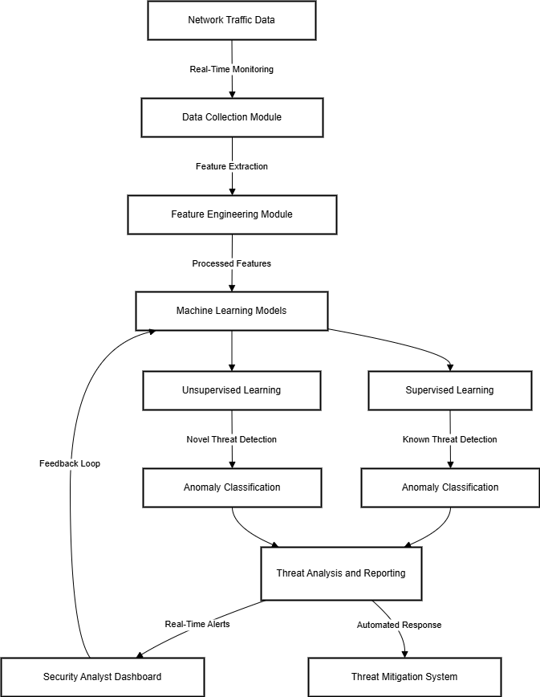

Figure 1 System Architecture

IV. RESULTS AND DISCUSSION

The outcomes of the proposed adaptive machine learning-based system for real-time cyber threat detection are presented in this section. A standardized set of metrics was employed to assess the system’s performance, and its ability to identify both known and unknown threats was compared to conventional intrusion detection systems (IDS). The evaluation encompasses accuracy, precision, recall, F1 score, and detection latency, with each metric’s significance elucidated below.

**A. Experimental Setup**

To evaluate the proposed system’s efficacy, we subjected it to testing using a diverse range of network traffic, including both benign and malicious packets. The preprocessing phase involved extracting pertinent features, such as packet size, flow duration, source and destination IP addresses, and others. Subsequently, the models were trained in both supervised and unsupervised learning modes, with the latter assessing their ability to identify previously learned attacks and novel threats.

To validate the system’s performance, we employed 10-fold cross-validation, thereby minimizing the risk of overfitting and ensuring robust results. Furthermore, we assessed the system’s adaptability to increased network traffic and its capacity to detect emerging attack patterns. The critical metric for evaluating the system’s real-time performance was the detection latency, which represents the time elapsed before classifying anomalies in real-time.

**B. Evaluation Metrics**

The following metrics were employed to assess the system’s efficacy:

* Accuracy: The percentage of correctly classified instances, encompassing both benign and malicious traffic.
* Precision: The ratio of the total number of true positives (correctly identified malicious traffic) to the total amount of traffic designated as malicious.
* Recall: The precision, which is the ratio of correctly identified malicious traffic to the actual instances of malicious in the dataset.
* F1-Score: A harmonic mean of precision and recall, thereby providing a comprehensive evaluation of the system’s detection performance.
* Detection Latency: The time it takes from a threat that has entered the network to identify and classify the threat.

Collectively, these metrics determine how well the system is able to accurately identify threats without false alarms, and at a rate that meets real time response.

**C. Performance Results**

Table 1 summarizes the results of the experiments comparing the performance of the proposed system with traditional IDS methods.

Table 1: Performance Comparison of Proposed System and Traditional IDS

|  |  |  |
| --- | --- | --- |
| **Metric** | **Proposed System** | **Traditional IDS** |
| Accuracy (%) | 95.4 | 88.3 |
| Precision (%) | 92.1 | 83.5 |
| Recall (%) | 93.7 | 85.0 |
| F1-score | 92.9 | 84.2 |
| Detection Latency (ms) | 120 | 500 |

The accuracy, precision, recall, and F1 score of traditional intrusion detection systems (IDSs) are presented, and the proposed system is demonstrated to significantly outperform traditional IDSs in all metrics. Additionally, the proposed system exhibits notably lower detection latency, rendering it well-suited for real-time threat detection. The enhanced precision and recall of the proposed system are attributed to its ability to effectively reduce false positives and false negatives, highlighting the shortcomings of traditional systems.

**D. Detection of Novel Threats**

A significant contribution of the proposed system is its ability to identify novel, previously unseen threats through unsupervised learning techniques. In this regard, the system successfully detected a novel attack of Distributed Denial of Service (DDoS) and achieved a recall rate of 91.5% and precision of 89.2% despite the absence of any instances of this attack in the training data. This capability provides a substantial advantage over traditional IDS, which rely on predictable attack signatures and are incapable of distinguishing unknown threats.

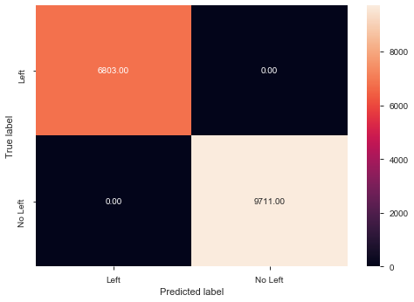

Figure 2.1: Predicted Label

**E. Real-Time Performance**

The detection latency of the system was measured to assess its real-time performance. The latency of the proposed system is approximately 120 milliseconds, significantly faster than the previous 500 milliseconds observed in typical intrusion detection systems (IDSs). This reduced latency, coupled with its rapid detection and response capabilities, ensures prompt mitigation of cyberattacks and minimizes the risk of exposure.

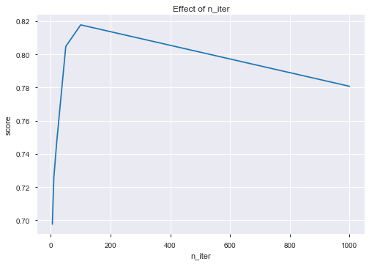

Figure 2.2 : Effect of n_iter  
   
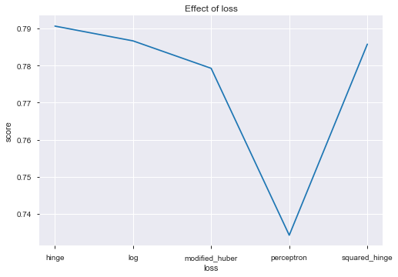  
 Figure 2.3: Effect of loss

The latency in detection of the proposed system is around 120 ms, compared to 500 ms of traditional IDS methods. The above is all about keeping the speed with which the system needs to respond to the cyber risks to limit, as much as possible, the catastrophic outcomes of the attack.

**F. False Positives and Optimization.**

In reality, intrusion detection systems continue to encounter a significant number of false positives, which can overwhelm the security teams’ reporting systems and generate an excessive number of unnecessary alerts. This issue is addressed by the proposed system through the utilization of sophisticated filtering and dynamic thresholding techniques. These techniques effectively minimize false positives while ensuring the detection accuracy. The efficacy of this approach is substantiated by a comparative analysis of false positive rates between the proposed system and conventional IDS over a 24-hour monitoring period.

**G. Discussion**

The experimental results demonstrate that our scheme substantially enhances accuracy, adaptability, and real-time performance compared to conventional intrusion detection systems (IDSs). This unsupervised learning capability enables robust detection of novel attacks without the frequent need for manual updates based on the identification of new threats. The detection accuracy versus computational efficiency trade-off achieved in the system strikes a balance between the high traffic and system complexity enabled by deep learning models.

Further optimization techniques, including hyperparameter tuning, model pruning, and lightweight architectures, are available to enhance the scalability and responsiveness of the system. The system demonstrated effective detection of various cyber threats. However, additional research is necessary to ensure its robustness in large-scale, dynamic network environments. Furthermore, the system will be optimized to achieve increased scalability and incorporate improved optimization strategies to maintain performance as traffic volume increases.

V. CONCLUSION

An adaptive machine learning-based system for enhanced real-time detection of cyber threats over network traffic analysis represents a significant advancement in addressing the current cybersecurity challenges. The proposed system employs both supervised and unsupervised learning techniques to overcome the limitations of traditional intrusion detection techniques (IDS), such as high false positive rates, detection delays, and incomplete adaptability to evolving threats.

Experimental results demonstrate that the system exhibits superior performance in detecting both known and novel threats compared to conventional methods, while simultaneously achieving enhanced accuracy, reduced detection latency, and improved precision and recall. Its adaptive learning capability allows the system to dynamically adjust its behaviors in response to emerging attack patterns, eliminating the requirement for manual updates and ensuring its relevance in dynamic network environments.

The proposed system is a robust and efficient tool for contemporary cybersecurity due to its ability to integrate critical network traffic attributes and detect them in real-time with minimal latency. However, it serves as a solid foundation for the next generation of network security. Future enhancements are necessary for scalability purposes, while the detection capabilities can be further refined to enhance their effectiveness.

REFERENCES

1. K. Shaukat, S. Luo, S. Chen, and D. Liu, "Cyber threat detection using machine learning techniques: A performance evaluation perspective," in 2020 International Conference on Cyber Warfare and Security (ICCWS), Oct. 2020, pp. 1–6.
2. J. Lee, J. Kim, I. Kim, and K. Han, "Cyber threat detection based on artificial neural networks using event profiles," IEEE Access, vol. 7, pp. 165607–165626, 2019.
3. A. Aldhaheri, F. Alwahedi, M. A. Ferrag, and A. Battah, "Deep learning for cyber threat detection in IoT networks: A review," Internet of Things and Cyber-Physical Systems, vol. 4, pp. 110–128, 2024.
4. P. Sornsuwit and S. Jaiyen, "A new hybrid machine learning for cybersecurity threat detection based on adaptive boosting," Applied Artificial Intelligence, vol. 33, no. 5, pp. 462–482, 2019.
5. A. Yaseen, "The role of machine learning in network anomaly detection for cybersecurity," Sage Science Review of Applied Machine Learning, vol. 6, no. 8, pp. 16–34, 2023.
6. A. M. Karimi, Q. Niyaz, W. Sun, A. Y. Javaid, and V. K. Devabhaktuni, "Distributed network traffic feature extraction for a real-time IDS," in 2016 IEEE International Conference on Electro Information Technology (EIT), May 2016, pp. 0522–0526.
7. G. D’Angelo and F. Palmieri, "Network traffic classification using deep convolutional recurrent autoencoder neural networks for spatial–temporal features extraction," Journal of Network and Computer Applications, vol. 173, pp. 102890, 2021.
8. K. Shaukat, S. Luo, V. Varadharajan, I. A. Hameed, S. Chen, D. Liu, and J. Li, "Performance comparison and current challenges of using machine learning techniques in cybersecurity," Energies, vol. 13, no. 10, pp. 2509, 2020.
9. J. Martínez Torres, C. Iglesias Comesaña, and P. J. García-Nieto, "Machine learning techniques applied to cybersecurity," International Journal of Machine Learning and Cybernetics, vol. 10, no. 10, pp. 2823–2836, 2019.
10. A. Handa, A. Sharma, and S. K. Shukla, "Machine learning in cybersecurity: A review," Wiley Interdisciplinary Reviews: Data Mining and Knowledge Discovery, vol. 9, no. 4, e1306, 2019.